Bài 4.1. Two Toggling LEDs
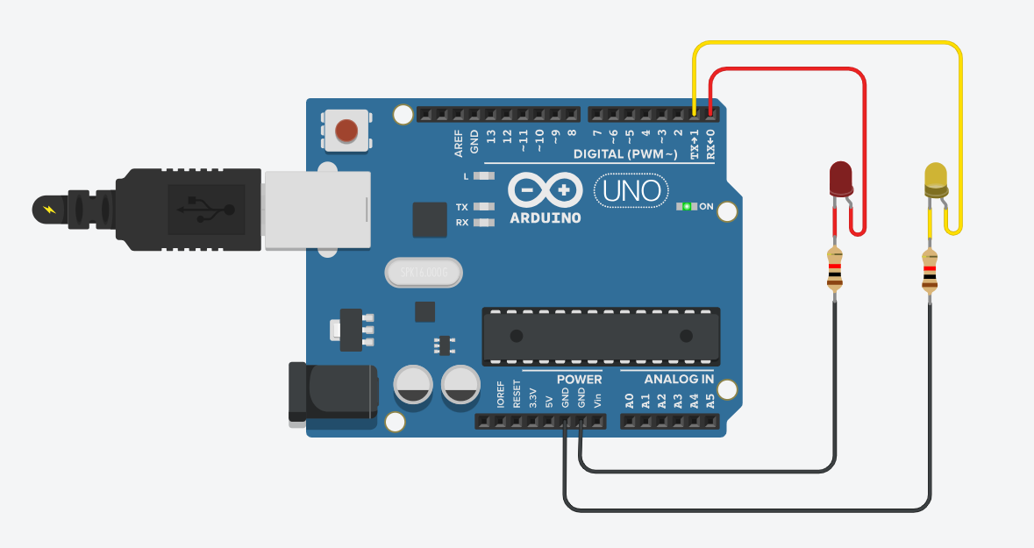
Hình 4.1. Two Toggling LEDs
Link Video Mô Phỏng:
https://drive.google.com/file/d/1PmoyjMCj9tJgyCxB-sK5xXUDXM_CFCbC/view?usp=drive_link
Bài 4.2. Multiple Blinking LED
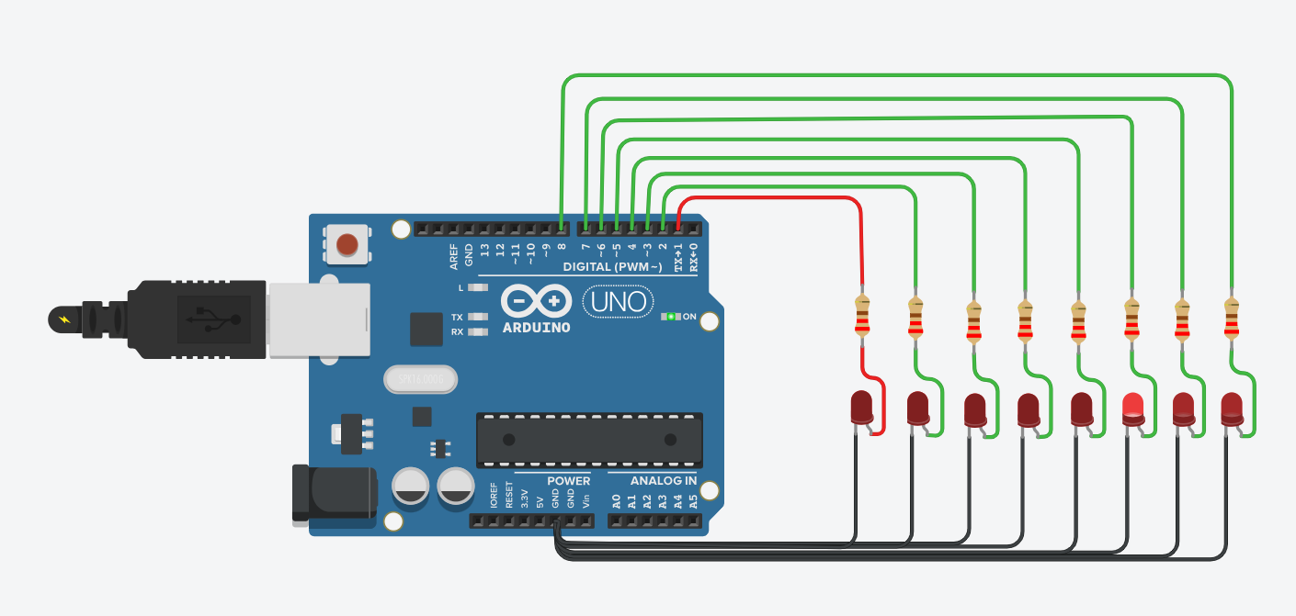
Hình 4.2. Multiple Blinking LED
Link Video Mô Phỏng:
https://drive.google.com/file/d/13i026hBCW-Yf1gjM2g_vta8vJYjFKsL1/view?usp=drive_link

Bài 4.3. Seven Segment LED
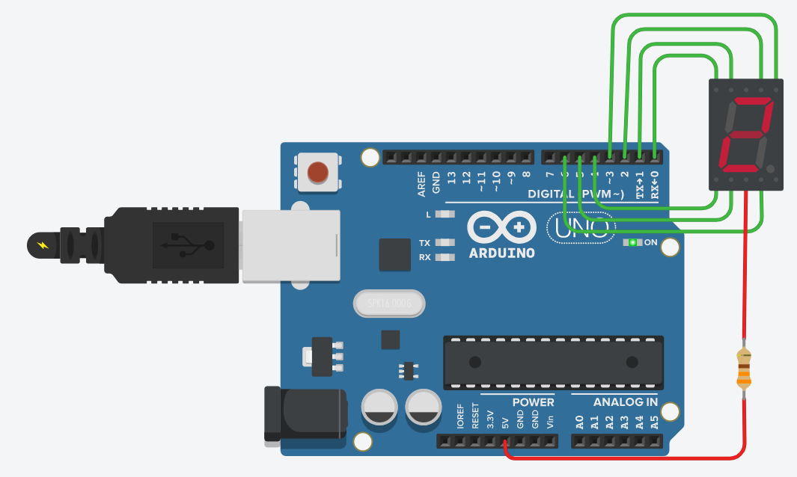
Hình 4.3. Seven Segment LED
Link Video Mô Phỏng:
https://drive.google.com/file/d/15FP-IfS0CohTdU63flpMdTgBRDZshnOX/view?usp=drive_link
Bài 4.4. Two Digit Number
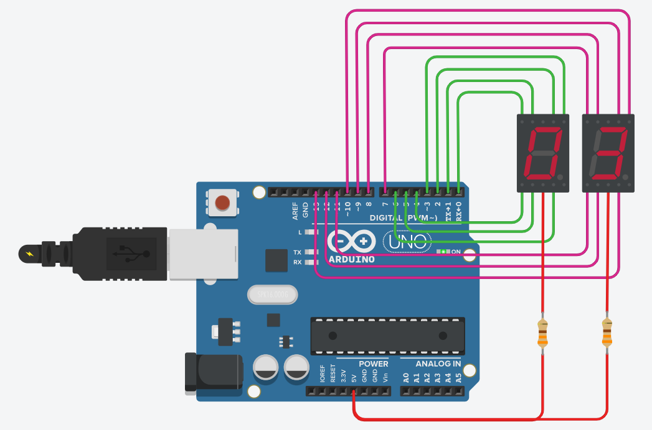
Hình 4.4. Two Digit Number
Link Video Mô Phỏng:
https://drive.google.com/file/d/13953n1B3JXOL6voadqPTjXGnEvbtxQpe/view?usp=drive_link

Bài 4.5. One Way Traffic Light
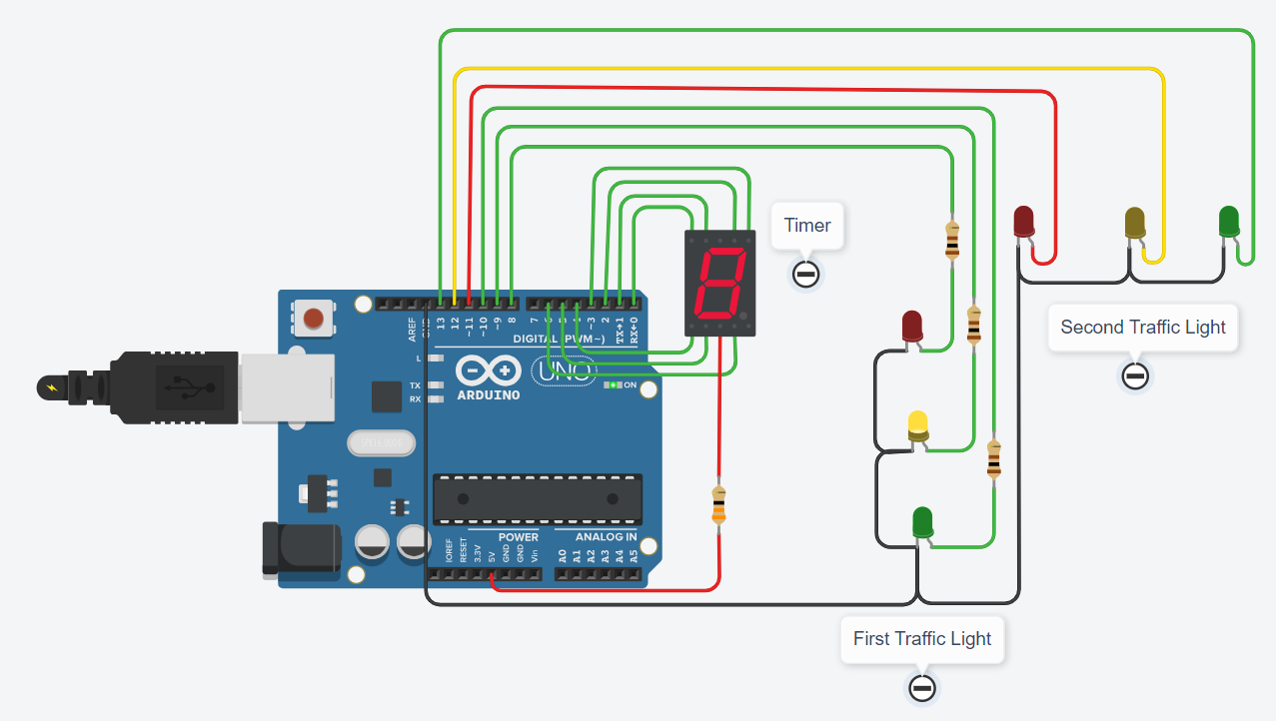
Hình 4.5. One Way Traffic Light
Link Video Mô Phỏng:
https://drive.google.com/file/d/1pK8AX6ZKtapzhaldhE-HPOUrcPfXDMFS/view?usp=drive_link

Bài 4.6. Two Way Traffic Light
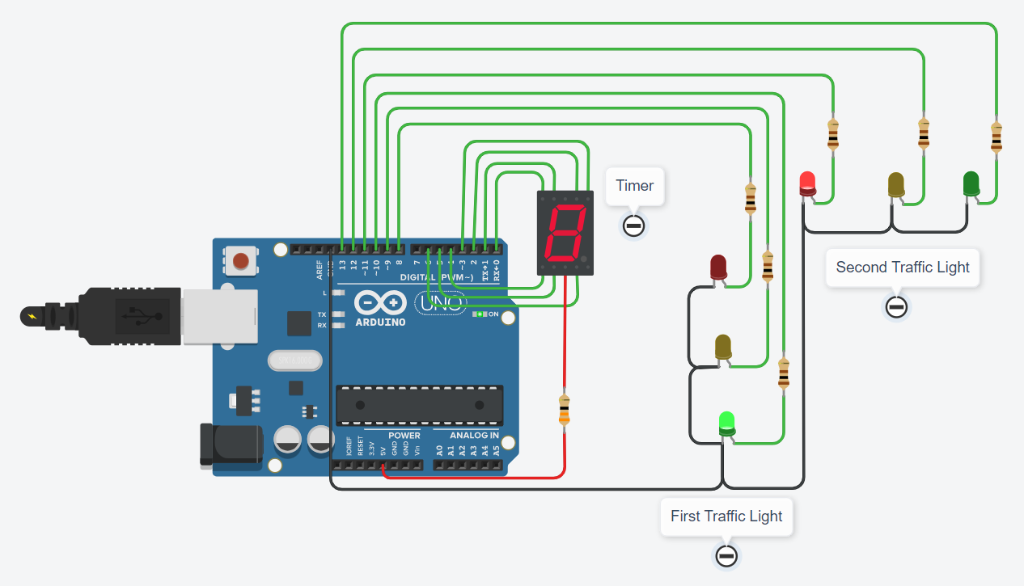
Hình 4.6. Two Way Traffic Light
Link Video Mô Phỏng:
https://drive.google.com/file/d/1vGwPkQwOfWidTahgKVNiFbxwHKvj2HT5/view?usp=drive_link

Bài 4.7. Traffic Light with Timer
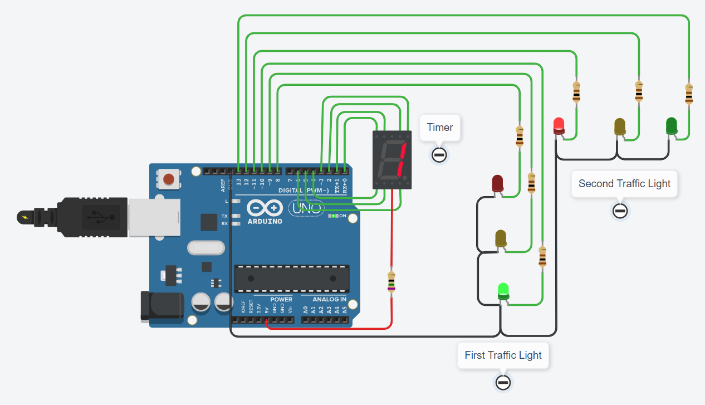
Hình 4.7. Traffic Light with Timer
Link Video Mô Phỏng:
https://drive.google.com/file/d/1FDM3YZxcrybVIuO5W6qFaEft5PDXiIYm/view?usp=drive_link
Bài 4.8. Analog Clock Project
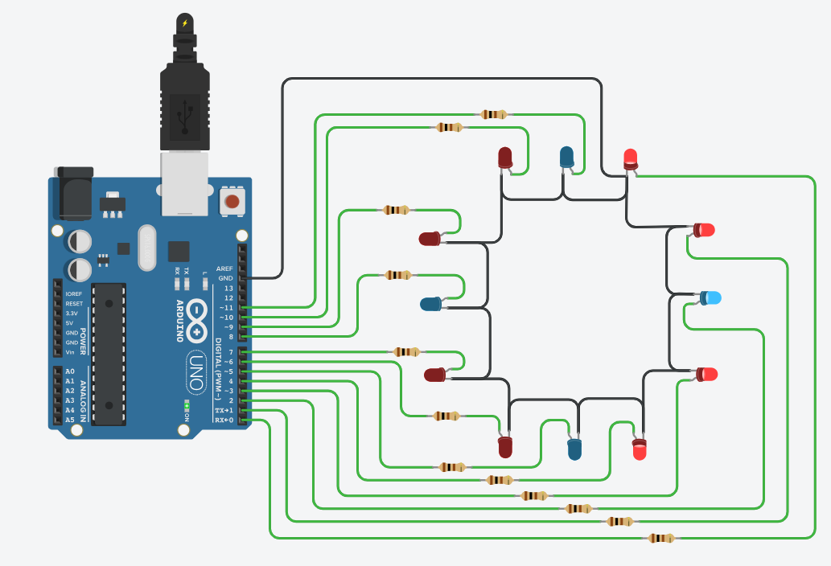
Hình 4.8. Analog Clock Project
Link Video Mô Phỏng:
https://drive.google.com/file/d/1AnuY-2XKXY8EYTwIUhx8YkmxVS1_puhq/view?usp=drive_link

Bài 4.9. Analog Clock with Second
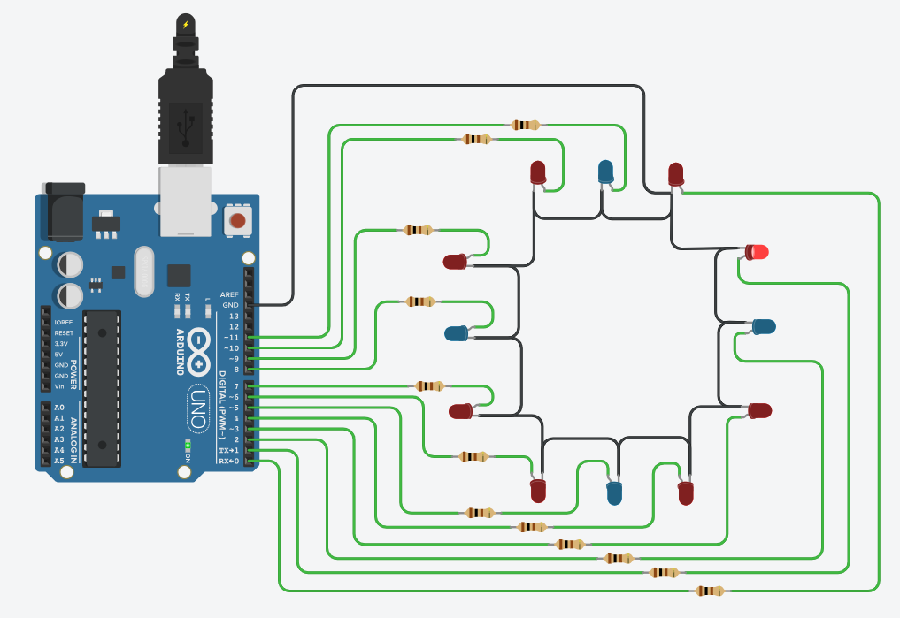
Hình 4.9. Analog Clock with Second
Link Video Mô Phỏng:
https://drive.google.com/file/d/16KJEEttGSy1VsxXTnfobEcC92lyq0yX0/view?usp=drive_link

Bài 4.10. Finalize the Analog Clock
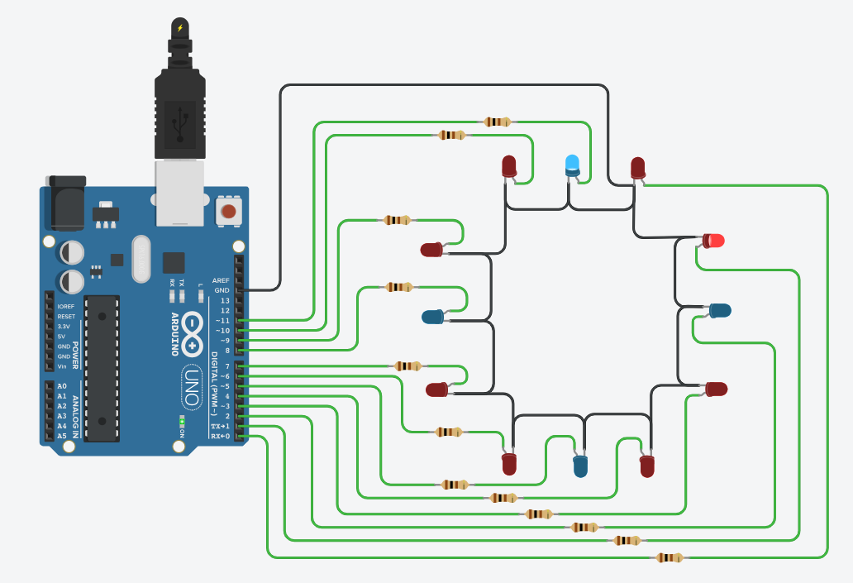
Hình 4.10. Finalize the Analog Clock
Link Video Mô Phỏng (tốc độ x1):
https://drive.google.com/file/d/12JSC0q6-UitqZdrxb5JqX8geKNILraBC/view?usp=drive_link
Link Video Mô Phỏng (tốc độ x200):
https://drive.google.com/file/d/1R5cI8Lo-7JyfM49LSx7hJLdMgvPRId9S/view?usp=drive_link

